## **Challenge Track 1: Quantum Computing for Atmospheric Chemistry in Egypt - Team 12**

# Aim:

Simulate how humidity affects **formation of sulfuric acid (H₂SO₄)** from SO₃ and H₂O clusters, and predict how this impacts **aerosol formation** in the Nile Delta.

# 

# 

# 

# 

# 

# 

# Solution Steps:

* Molecular geometries for: SO₃, H₂O, H₂SO₄
* VQE (to compute molecular ground state energy) for: SO₃, H₂O, H₂SO₄

VQE workflow:

* + [Map problem to quantum circuits and operators](https://quantum.cloud.ibm.com/docs/guides/map-problem-to-circuits)
  + [Optimize for target hardware](https://quantum.cloud.ibm.com/docs/guides/optimize-for-hardware)
  + [Execute on target hardware](https://quantum.cloud.ibm.com/docs/guides/execute-on-hardware)
  + [Post-process results](https://quantum.cloud.ibm.com/docs/guides/post-process-results)
* Compute reaction energies using: ΔE = E(H₂SO₄) − (E(SO3) + n⋅E(H2O))
* Compute reaction using: k(T)=A⋅e−ΔE/RT  
  A: Pre-exponential factor (can assume ~10¹³ s⁻¹ for gas-phase reactions)  
  R: Gas constant = 8.314 J/mol·K  
  T: Temperature in Kelvin (e.g., 298 K)  
  ΔE: Activation energy in J/mol

Ea​=ETS​−EReactants​  
EReactants = E(SO3) + n E(H20)  
Etransition state =

**Aerosol Nucleation and Growth**Higher H₂SO₄ formation rate → more nucleation → more aerosols.  
**J=A⋅exp(−kB​TΔG∗​)**

# Results:

# **Experiment setup:** Framework: Qiskit Simulator: AerSimulator, FakeBrisbane Quantum Algorithm: VQE

#### Noisy simulation (FakeBrisbane) H2O:

## ground energy: -5.194307 Ha for (orbital reduction: (4,3)) === GROUND STATE ENERGY === For orbital reduction (4,4) * Electronic ground state energy (Hartree): -84.15998814069 - computed part: -6.162434053748 - FreezeCoreTransformer extracted energy part: -60.660703391873 - ActiveSpaceTransformer extracted energy part: -17.336850695072 ~ Nuclear repulsion energy (Hartree): 9.189533762935 > Total ground state energy (Hartree): -74.970454377758

# 

# 

# 

# 

# 

# SO3:

Problem of number of qubits: 46 (executing crash)

Solve it by reducing the number of qubits using: freezing the core electrons (30) + orbital reduction (8) + 2-qubit tapering (6)  
Result: Depending on the **basis set**, **active space**, and **symmetries**, we can go from 46 qubits to **6 to 12 qubits**.

the percentage reduction in the number of qubits: Approximately 86.96% reduction in the number of qubits.

Reduction (%)=[(46−6​)/46]×100

Ground energy estimated for SO3: -7.333326 Ha

# 

H₂SO₄:

Conclusion: Reducing the number of qubits in a quantum simulation. by selecting a smaller active space, significantly decreases the number of terms in the qubit Hamiltonian.

For example for H2SO4: 1840086 terms, after core freezing: 468996, after orbital reduction: 2628

the **percentage reduction** in the number of terms: **Approximately 99.86% reduction** in the number of terms.

Reduction (%)=[(1840086−2628​)/1840086]×100≈99.8572%

This simplifies the quantum circuit, reduces noise sensitivity, and improves the feasibility of running on near-term quantum devices, while maintaining key chemical accuracy if the active space is chosen wisely.

Ground state energy: -12.867377700087468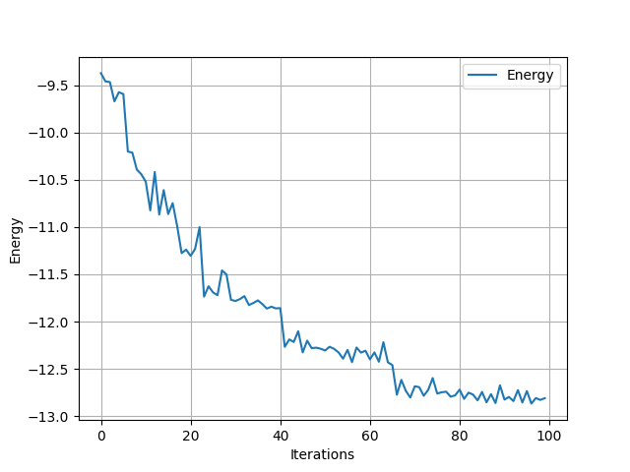

## **reaction energies: ΔE = E(H₂SO₄) − (E(SO3) + n⋅E(H2O))**

## cluster_1, cluster_2, cluster_3

# (0.33974500000000063, 4.854562, 10.048868999999998)

# 

## Ideal simulation

### H20:

Reference energy: -74.96302313846124 Ha

> Total ground state energy (Hartree): -74.970454377758

Ground energy estimated for H2O: -74.81603391853463 Ha

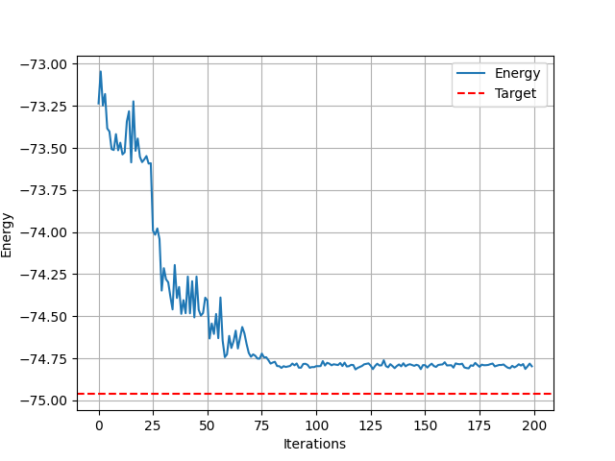

### SO3:

Reference energy: -614.2315439258371 Ha

> Total ground state energy (Hartree): -614.314798498332

Ground energy estimated for SO3: -613.7954993302574

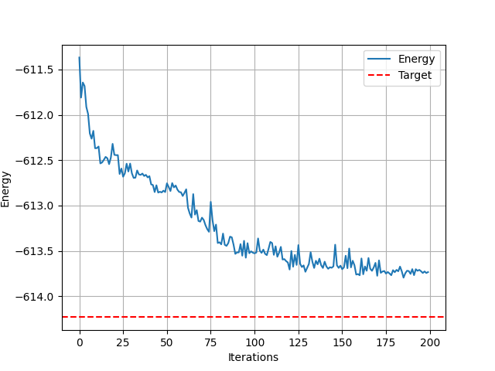

## 

## 

## **H2SO3:**

Reference energy: -689.2267909831724 Ha

> Total ground state energy (Hartree): -689.251706941207

Ground energy estimated for H2SO3: -688.1991870300016

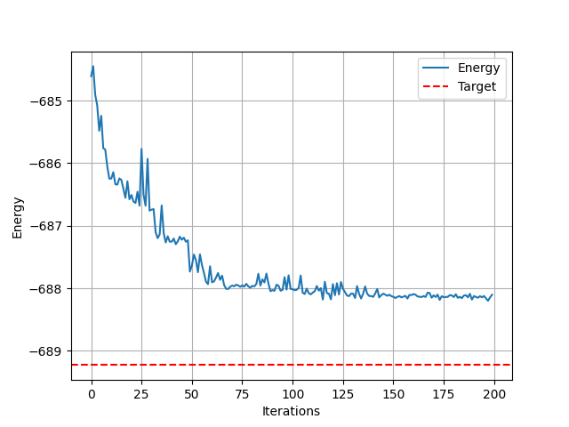

## 

## 

## 

## 

## 

## 

## 

## 

## **Presentation Content:**

### **Slide 1: Title & Team (10–15 sec)**

**Title**: *Quantum Simulation of Sulfate Aerosol Formation under High Humidity***Challenge**: Quantum Modeling of Humidity-Dependent Reaction Kinetics in the Nile Delta

### **Slide 2: Problem Context (30–40 sec)**

* **Motivation**:  
  + The **Nile Delta** has **>80% humidity year-round**, enhancing sulfate aerosol formation.
  + Sulfate aerosols affect **climate**, **air quality**, and **human health**.
* **Reaction Pathway**:  
   SO₂ + OH → HOSO₂ → SO₃ → SO₃ + nH₂O → H₂SO₄ (with n = 1, 2, 3)
* **Goal**:  
   Simulate how **humidity (60–100%)** affects the energy and rate of SO₃ + nH₂O → H₂SO₄

### **Slide 3: Quantum-Classical Hybrid Pipeline (60 sec)**

* **Quantum Part**:  
  + Used **VQE** to compute ground-state energies of:  
    - H₂O, SO₃, H₂SO₄
  + Challenge with big molecule (SO₃, H₂SO₄) **qubit reduction** and **term reduction**:  
    - SO₃: Qubits: 46 → 6

freezing the core electrons (30) + orbital reduction (8) + 2-qubit tapering (6)  
the **percentage reduction in the number of qubits 86.96%**

* + - H₂SO₄: Hamiltonian terms: 1.8M → 2628

1840086 terms, after core freezing: 468996, after orbital reduction: 2628   
the **percentage reduction** **99.86%**

* **Energy Difference (ΔE)**:  
  + ΔEₙ = E(H₂SO₄) – [E(SO₃) + n·E(H₂O)]
  + Used ΔE as **activation energy proxy**

### **Slide 4: Humidity-Dependent Reaction Rates (60 sec)**

* **RH Modeling**:  
  + Interpolated RH (x = 0 at 60%, x = 1 at 100%)

Used quadratic basis weights:  
  
w1 = (1 - x)^2

w2 = 2x(1 - x)

w3 = x^2

* **Effective Activation Energy**:  
  + ΔE_eff(RH) = w1·ΔE₁ + w2·ΔE₂ + w3·ΔE₃
* **Reaction Rate**:  
  + r(RH)∝exp⁡(−ΔEeffkT)r(RH) \propto \exp\left( -\frac{\Delta E_\text{eff}}{kT} \right)r(RH)∝exp(−kTΔEeff​​)

### **Slide 5: Results & Visualization (45 sec)**

* **Plot**: RH (60–100%) vs **Normalized Reaction Rate**
* **Insight**:  
  + Rate increases sharply with RH due to clustering
  + Quantum data shows **nonlinear behavior** → only captured with multi-cluster modeling

### **Slide 6: Impact & Mapping to Aerosol Nucleation (45 sec)**

* Higher RH → more clustering → faster sulfate formation
* Can map rate increase to **nucleation probability**
  + Useful for **climate models** and **air pollution forecasting**
* **Quantum advantage**:  
  + Enables accurate energy estimates for **complex hydrogen-bonded systems**
  + Scalable to other reactions (e.g. nitric acid, ammonia)

### **Slide 7: Conclusion (30 sec)**

* Built a full **quantum-classical pipeline**
* Simulated SO₃ + nH₂O → H₂SO₄ for n = 1–3
* Predicted RH-dependent rates and mapped to nucleation insights
* First step toward **quantum-enabled climate chemistry modeling**

# 

# 

# Credit:

Nile delta image:

<https://en.wikipedia.org/wiki/File:Niledelta_33.svg>

Sulfate formation image: <https://www.sciencedirect.com/science/article/abs/pii/S1352231024002814>

Sulfate aerosol size image: <https://www.researchgate.net/figure/Sulfate-aerosol-particle-size-diagram_fig3_258542011>  
Data: Computational Chemistry Comparison and Benchmark DataBase